**A BLOG ON THE DIFFERENCE BETWEEN DOCUMENT AND WINDOWS OBJECT**

## **Window Object**

The Window object is a global object in client-side JavaScript, representing the browser window containing a DOM document and acting as the root of the document object model.

The window object, supported by all browsers, represents the browser’s window and automatically includes global JavaScript objects, functions, and variables as members.

The Window object is responsible for managing global variables, functions, and objects, providing methods for browser interaction and managing properties related to frames, tabs, or windows, such as alert(), confirm(), setTimeout(), and setInterval().

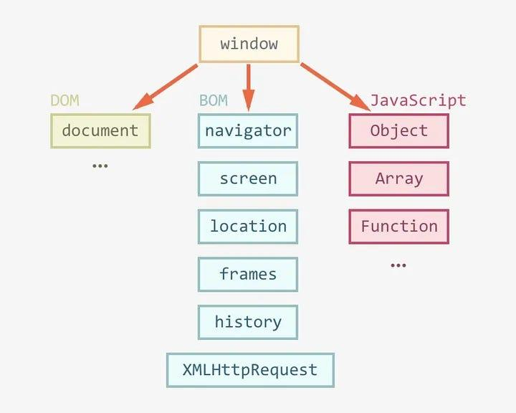

Few properties and methods of window objects are,

***Properties***

window.innerHeight - the inner height of the browser window (in pixels)

window.innerWidth - the inner width of the browser window (in pixels)

***Methods***

window.open() - open a new window

window.close() - close the current window

window.moveTo() - move the current window

window.resizeTo() - resize the current window

# **Document Object**

The Document object is the HTML document that appears in the browser window and serves as an interface for interacting with the web page’s content. The browser generates a Document Object Model of a web page upon loading it.

The document object represents a web page that is loaded in the browser. By accessing the document object, we can access the element in the HTML page. With the help of document objects, we can add dynamic content to our web page. The document object can be accessed with a **window.document** or just **document.**

**Syntax:**

Document.property_name;

The DOM is a logical tree in a document, with methods allowing programmatic access to change its structure, style, or content.

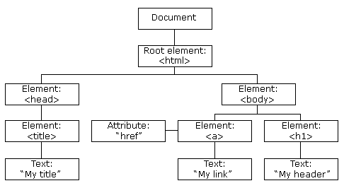

The DOM manipulation tool offers methods to access and manipulate the structure and content of a document, such as getElementById(), querySelector(), createElement(), and innerHTML. It represents the entire HTML document as a node tree, with the Document object as the root node. It allows dynamic updates and interactions with web page content.

Few properties and methods of Document Object Model,

***Properties***

*element.innerHTML = new html content/*/Change the inner HTML of an element

*element.attribute = new value*//Change the attribute value of an HTML element

***Methods***

*document.createElement(element*//Create an HTML element

*document.removeChild(element)*//Remove an HTML element

